Bound Brook High School Alumni Newsletter
BBHS Alumni Association - Hall of Fame
Memorial Day Special Issue
May 2025 Issue 88
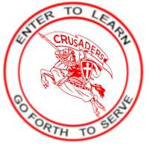
In This Issue
Memorial Day- Why We Observe-
Pages 1-2
Three True Crusader Heroes Pages 3-8
In Memoriam Page 9

Why do we observe Memorial Day? 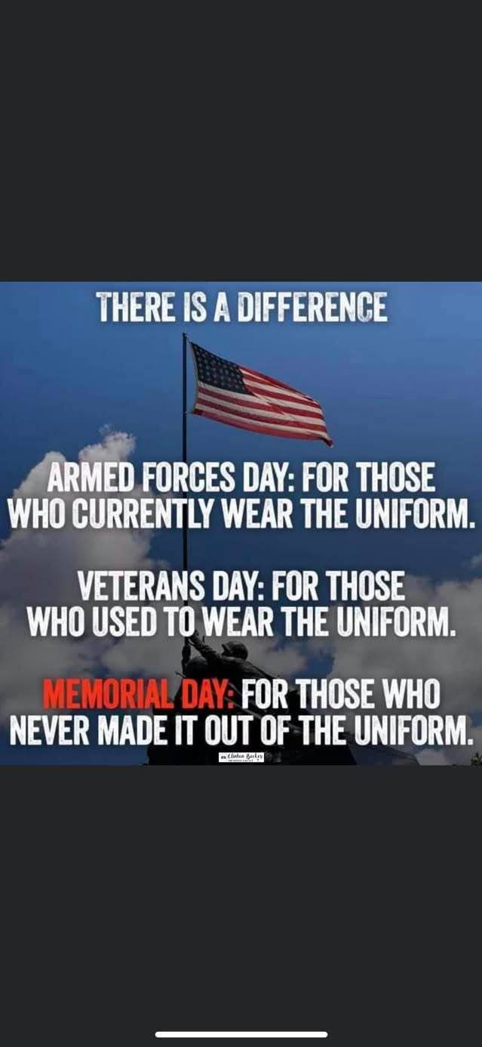 Decoration Day- The forerunner to Memorial Day On May 5, 1868, General John A. Logan, leader of an organization for Northern Civil War veterans, called for a nationwide day of remembrance later that month. “The 30th of May, 1868, is designated for the purpose of strewing with flowers, or otherwise decorating the graves of comrades who died in defense of their country during the late rebellion, and whose bodies now lie in almost every city, village and hamlet churchyard in the land,” he proclaimed.
The date of Decoration Day, as he called it, was chosen because it wasn’t the anniversary of any particular battle. On the first Decoration Day, General James Garfield made a speech at Arlington National Cemetery, and 5,000 participants decorated the graves of the 20,000 Civil War soldiers buried there.
Many Northern states held similar commemorative events and reprised the tradition in subsequent years; by 1890 each one had made Decoration Day an official state holiday. Southern states, on the other hand, continued to honor the dead on separate days until after World War I.
History of Memorial Day
Memorial Day, as Decoration Day gradually came to be known, originally honored only those lost while fighting in the Civil War. But during World War I the United States found itself embroiled in another major conflict, and the holiday evolved to commemorate American military personnel who died in all wars, including World War II, The Vietnam War, The Korean War and the wars in Iraq and Afghanistan.
For decades, Memorial Day continued to be observed on May 30, the date General Logan had selected for the first Decoration Day. But in 1968, Congress passed the Uniform Monday Holiday Act, which established Memorial Day as the last Monday in May in order to create a three-day weekend for federal employees. The change went into effect in 1971. The same law also declared Memorial Day a federal holiday.
The first national observance of Memorial Day occurred on May 30, 1868.^{[6]} Then known as Decoration Day and observed on May 30, the holiday was proclaimed by Commander in Chief John A. Logan of the Grand Army of the Republic to honor the Union soldiers who had died in the American Civil War.^{[7]} This national observance followed many local observances which were inaugurated between the end of the Civil War and Logan's declaration. Many cities and people have claimed to be the first to observe it. However, the National Cemetery Administration, a division of the Department of Veterans Affairs, credits Mary Ann Williams with originating the "idea of strewing the graves of Civil War soldiers—Union and Confederate—with flowers.^{[8]}
Official recognition as a holiday spread among the states, beginning with New York in 1873.^{[8]} By 1890, every Union state had adopted it. The world wars turned it into a day of remembrance for all members of the U.S. military who fought and died in service. In 1968, Congress changed its observance to the last Monday in May, and in 1971 standardized its name as "Memorial Day.” Two other days celebrate those who have served or are serving in the U.S. military: Armed Forces Day, which is earlier in May, an unofficial U.S. holiday for honoring those currently serving in the armed forces, and Veterans Day on November 11, which honors all those who have served in the United States Armed Forces.^{[9]}

Feature Article Pages 3- 8
Who Was the First Alumnus to Die in Vietnam? Was it Antanas A. “Tony” Prizgintas, BBHS Class of 1963?

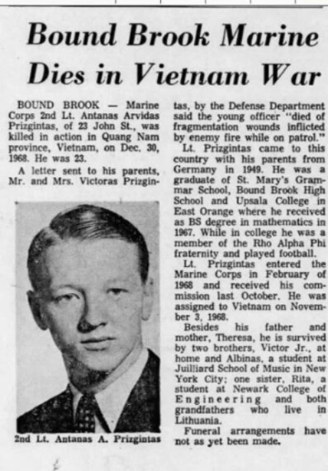
Antanas Arvida Prizgintas
Second Lieutenant
A CO, 1ST BN, 5TH MARINES, 1ST MARDIV, III MAF
United States Marine Corps
Bound Brook, New Jersey
November 01, 1945 to December 30, 1968
ANTANAS A PRIZGINTAS is on the Wall at Panel W35, Line 9

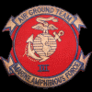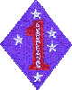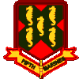 | 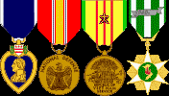

United States Marine Corps, 2nd Lt. Killed in action December 30, 1968.
In early January, 1969, word started spreading around the town that a local boy had been killed in action in Vietnam. When we heard that it was Tony Prizgintas many of his friends were shell shocked by the news. He was well liked and many of his high school buddies were still in or around town. Tony was killed in action on December 30, 1968.He had been in the jungles for less than three months before making the ultimate sacrifice as a USMC lieutenant.
The school believed that Tony was the first BBHS alumnus to die in Vietnam

Antanas Prizgintas was always called “Tony,” as we grew up in Bound Brook. He used to tell us that his parents had skipped away from the Communists who were taking over Hungary following WWII. His family ended up in Bound Brook because a relative of his was the priest for St. Mary’s Church. His mother, Theresa, was the organist and music teacher at St. Mary’s School for many years.
Tony’s goal as he grew up was to be like the rest of the boys he played with and schooled with in town. He wanted to be an American. Even though he was slightly built, he joined the BBHS Wrestling team and by his Senior year, 1963, he was wrestling Varsity in one of the light-weight classes. In the Spring he joined the Track and Field program, competing in the low hurdles and the half-mile races.
After graduating from Bound Brook High School, he enrolled at Upsala College in East Orange, where he earned his B.S. degree in Mathematics in 1967. While there he continued making friends in his fraternity and played football at the college level, even though he weighed less than 150 pounds!
Lt. Prizgintas entered the Marine Corps in February 1968 and was commissioned in October. He was assigned to Vietnam on November 3, 1968. Tony was thought to be the first BBHS alumnus to die when he died of fragmentation wounds inflicted by the Viet Cong on December 30, 1968.

*************************************************************************************

Was he the second Crusader to give his life in Vietnam?
Michael John Hayes, Jr 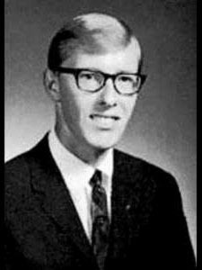
Private First Class
M CO, 3RD BN, 4TH MARINES, 3RD MARDIV, III MAF
United States Marine Corps
Bound Brook, New Jersey
March 23, 1948 to March 14, 1969
MICHAEL J HAYES Jr is on the Wall at Panel W29, Line 37

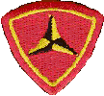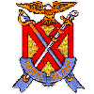
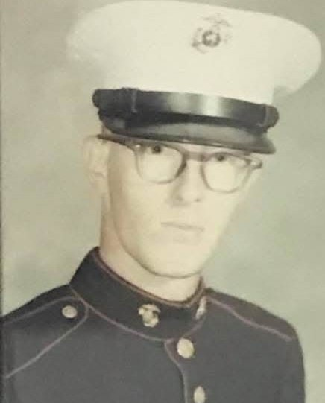
Michael John Hayes, Jr.- BBHS Class of 1967
Just a few months after Tony Prizgintas was killed more bad new came from that faraway land called Vietnam. PFC Mike Hayes was killed on March 14, 1969. Michael J. Hayes, BBHS Class of ’67, moved to Bound Brook from Dunellen, in 1963. He had moved into the Codrington Apartments with his mother and father and his younger brother, Ricky when he was 14. He seemed to fit right in with the new friends he was making.
Mike also wanted to be like one of the guys, and he quickly got to know the kids that lived in the apartments and around the Codrington area of Bound Brook. He was a regular at the Park Luncheonette, playing pinball and having fun with the local gang of kids who were already there. When summer came, he shifted to Codrington Park, like most other kids, having fun at the pool and playing on the summer Park Softball team that competed against other local playgrounds. One of his happiest moments of the summer was when he helped the park team defeat the Dunellen team with many of his former friends. Mike began working at part-time jobs in the area. He worked at the Food Fair doing odd jobs and patrolling the nearby area for abandoned shopping carts. One summer he worked for a short time at Park Luncheonette, but did not stay very long at it.
Mike graduated from BBHS in June 1967 and started looking for full-time jobs. He took a job working at Art Color in Dunellen, soon after graduation. Late 1967 and early 1968 were tough times for young men because of the draft that was taking so very many non-college men into the military. At that time all high school graduates and out of college men had to sign up the draft. Supposedly there was a birth date lottery by the federal government to get enlistees for all branches of the service being started. However, that was not in effect yet.
Then mail from the U.S. Government came to his apartment. Mike, like many others, received his notification to go to Newark, NJ to have his pre-draft physical to see if he qualified for the armed services. A busload of Bound Brook locals went to Newark for a full day of tests, both physical and mental, to rate their ability serve their country. On the way back from Newark, we sat in the back of the bus and talked about what we would do if drafted. Mike said, “I will join the Marines if I passed my physical. I don’t want the government to choose what branch I go to.” It was probably the last time I spoke with Mike.
He joined the Marines in 1968, and went to basic training to learn the “Marine way.” After Basic, Mike was sent to Vietnam as a radio man with the Third Battalion, Fourth Marine Division in December 1968. Mike was only there for three months before he died.
He was thought to have been the second BBHS alumnus to die there.

Who was the first BBHS alumnus killed in Vietnam?
Read this account to find the answer
John Francis Dudash
Colonel
333RD TAC FTR SQDN, 355TH TAC FTR WING, 7TH AF
United States Air Force
Manville, New Jersey
November 25, 1929 to June 07, 1974
(Incident Date April 26, 1967)
JOHN F DUDASH is on the Wall at Panel 18E, Line 92

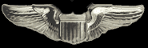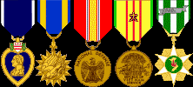
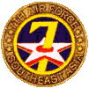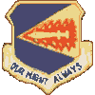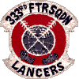

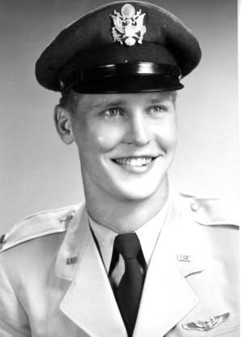
John F. Dudash- BBHS Class of 1947
Missing in Action, But Not Forgotten
Following the end of the Vietnamese conflict, it was believed that Bound Brook High School had been very lucky to only lose two alumni during the war. However, a few years went by, and then words went out that there might have been a third Crusader that gave his life.
John Dudash was born on November 25, 1929, and grew up in Manville. He attended Sacred Heart Elementary School, and since Manville had no secondary school at the time children of high-school age went to Bound Brook. John graduated from Bound Brook High School in 1947. While in high school, he was active in sports and participated in baseball, which he hoped would be a future career. He continued his education at the College of Emporia in Kansas until 1949, when he transferred to Villanova.
John enlisted in the U.S. Air Force from Manville, in 1950, and was commissioned in 1953. After completing basic training in Texas, he was stationed at six different bases around the world from Ohio to Germany and Japan. Eventually, he attained the rank of Colonel. Between 1965 and 1967 Dudash was a pilot of the F105 Thunderchief, flying missions against North Vietnam. His mission was to bomb military targets in North Vietnam as part of Operation Rolling Thunder. On the last mission flown by Col. Dudash, with Major Alton Meyer in the rear seat, his F105 was hit by enemy fire in Vinh Phu Province, northwest of Hanoi. Meyer, as the rear seater, ejected first and was captured immediately. He landed about 45 miles northwest of Hanoi, and the plane continued in a southeasterly direction with Dudash still at the controls. Although the Air Force later located the precise location of the downed aircraft, the fate of John was uncertain. While Meyer watched, the pieces of the plane fell to earth about five miles from the ejection coordinates of Meyer and finally crashed. Whether John successfully ejected was doubtful, but he was classified Missing in Action, and it was felt that the Vietnamese could account for him.
In the spring of 1973, 591 Americans were released from POW camps and among them was Alton Meyer. Although the area where the plane crashed was less populated the Vietnamese would not fail to notice the crash and investigate. Yet, the Viets denied any knowledge of John Dudash for more than a decade.
Colonel Dudash was declared missing in action on April 26, 1967. He continued in that status until 7 June 1974, when the Air Force declared him dead, presuming his date of death to have occurred for the purpose of termination of pay and benefits and payment of death benefits. At last, his remains were repatriated on June 3, 1983, and positively identified on June 27, 1983. He was buried in Arlington National Cemetery. He was awarded numerous medals, including the Air Medal. Finally, his family could rest, knowing what John’s fate was.
Colonel John Dudash became the answer to the ominous question, “Who was the first Bound Brook alumni to be killed in action in Vietnam?”

*** If you get the opportunity to visit the Vietnam Wall in Washington, D.C. or at the Traveling Wall exhibit do so. If you’d like to see where our three alumni are listed on the wall, look at the opening paragraph to find the position each of these deceased Crusaders.

In Memoriam
Class of 1949 Alice L. Zarecki (4/9)
Class of 1955 Rita Barber Gilrain (5/9)
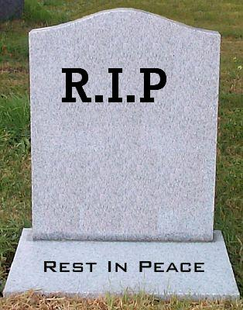
Class of 1959 Ronald Slahetka (12/23)
Class of 1960 Patricia Gibbons Perhac (6/25/23)
Class of 1960 Victoria Albanese D’Ovidio (2/9/24)
Class of 1960 Carol Apgar Poole (8/15/24)
Class of 1960 Neil Geary (11/24/24)
Class of 1960 Ronald Vaughn (4/22)
Class of 1961 Rylon Swain (12/18/24)
Class of 1965 William Dupree (5/6)
Class of 1968 John Kelly (3/8)
Class of 1971 Joseph Shurin (1/1)
Class of 1973 Denise Esposito Schulz (3/22)
Class of 1973 Jack LaMaestra (4/28)
Class of 1973 Janet Galpin (5/16)
Class of 1975 Ken Stone (4/27)
Class of 1978 Peter Tomaro (2/26)
Class of 1979 Theodore Vliet (1/26)
Class of 1994 David Fisher (1/31)

